24 Mars 2026

Project Report

Research Project - Optimization of Minimum Inventory : Demand Forecasting and Lead Time Analysis


Students:
- Salah Eddine OBADAH
- Samy TALEB
- Walid MOUH MOUH

Supervisors :
- Mourad TERZI
- Nabil ABSI

! Confidentiality Notice !
In accordance with confidentiality agreements and non-disclosure obligations related to this industrial project, the company name, certain internal identifiers, and several organizational references have been intentionally anonymized in this document. All analyses, methods, results, and conclusions presented remain strictly identical to those of the original version.

Abstract

English
Groupe X is a French distributor of raw materials, hygiene products, and packaging for the food service industry. Managing minimum stock levels across thousands of product references is a core operational challenge, made harder by highly irregular and intermittent demand patterns. This project develops a data-driven approach to improve demand forecasting and minimum stock computation for Site 1 of the group's distribution network.
The methodology follows five steps. First, an ABC/XYZ classification segments products by volume priority and demand variability, using delivered quantities and monthly coefficients of variation. Product lifecycle information (such as creation and cancellation dates) is integrated to correct classification bias on short-lived references. Second, seasonality is detected using autocorrelation (ACF) and partial autocorrelation (PACF) analysis on monthly demand series. Third, demand is forecast using exponential smoothing methods (simple, Holt, and Holt-Winters) selected per product based on detected trend and seasonality. Fourth, lead time statistics are computed per product from purchase order data. Finally, three minimum stock formulas of increasing complexity (F1, F2, F3) are applied, progressively accounting for demand and lead time uncertainty at a 99% service level.
Results show that F3, the most complete formula, achieves fill rates above 94% for high-volume categories. The study also identifies key limitations of exponential smoothing on intermittent demand series and motivates future work using advanced methods such as the Syntetos-Boylan Approximation and neural networks.
Keywords: demand forecasting, inventory management, ABC/XYZ classification, exponential smoothing, intermittent demand, minimum stock, supply chain.

Français
Le Groupe X est un distributeur français de matières premières, de produits d'hygiène et d'emballages destinés aux métiers de bouche. La gestion des stocks minimums sur des milliers de références constitue un défi opérationnel majeur, rendu plus complexe par des profils de demande irréguliers et intermittents. Ce projet développe une approche fondée sur les données afin d'améliorer la prévision de la demande et le calcul du stock minimum pour le site 1 du réseau de distribution du groupe.
La méthodologie repose sur cinq étapes : une classification ABC/XYZ combinant priorité volumique et variabilité de la demande, une analyse de saisonnalité par autocorrélation (ACF et PACF), une prévision par lissage exponentiel adapté à chaque produit, une analyse des délais de livraison, et enfin le calcul de trois formules de stock minimum (F1, F2, F3) à un niveau de service de 99 %.
Les résultats montrent que la formule F3 atteint des taux de couverture supérieurs à 94 % pour les catégories à fort volume. L'étude identifie également les limites du lissage exponentiel sur les demandes intermittentes et ouvre des perspectives vers des méthodes avancées telles que l'approximation de Syntetos-Boylan et les réseaux de neurones.
Mots-clés : prévision de la demande, gestion des stocks, classification ABC/XYZ, lissage exponentiel, demande intermittente, stock minimum, chaîne d'approvisionnement.

SOMMAIRE

Abstract 2
English 2
Français 2
1. Introduction 6
1.1 Industrial Context 6
1.2 Business Problem 7
1.3 Project Objectives 7
1.4 Approach Overview 7
2. Understanding the Data and Initial Approach 8
2.1 Data Overview 8
2.2 Key Observations 8
2.3 Initial Forecasting Approach 9
2.4 Initial Limitations 10
3. From Initial Model to Improved Solution 11
3.1 Working Methodology 11
3.2 Integrating Business Features to Improve ABC/XYZ Classification 11
3.3 Handling Seasonality: From ACF to PACF 12
3.4 Forecasting Strategy Evolution 13
Exponential smoothing — revisited. 13
Testing SBA. 13
Neural network. 13
3.5 Model Evaluation Strategy 14
4. Results and Business Insights 14
4.1 Model Performance Comparison 14
Exponential Smoothing with ACF 15
Exponential Smoothing with PACF 15
4.2 Interpretation of Results 16
4.3 Impact on Inventory Decisions 17
4.4 Key Takeaways 17
5. Limitations and Perspectives 18
5.1 Limitations 18
5.2 Future Work 19
6. Conclusion 19
Appendix — Technical Focus 20
1. Seasonality Analysis: ACF and PACF 20
2. Forecasting Methods 20
Part 1 — Exponential Smoothing: improvements. 20
Part 2 — SBA. 21
Part 3 — Bidirectional LSTM with Zero-Inflated head. 21
Architecture. 21
Input features. 21
Target and training. 21
References 22

1. Introduction

1.1 Industrial Context
Groupe X is a French distributor specializing in raw materials, hygiene products, and packaging for the food service industry. The company supplies thousands of product references to restaurants, caterers, and retail partners across multiple warehouse sites. Like many distributors operating in business-to-business markets, Groupe X faces a fundamental tension between product availability and stock efficiency [1].
Inventory management in distribution networks is well-documented as a complex problem. Demand varies across products, seasons, and customer segments. Holding too much stock generates unnecessary costs. Holding too little causes service failures. For a distributor of Groupe X's scale, finding the right balance requires both reliable demand forecasting and structured decision rules for stock replenishment [2].

1.2 Business Problem
The core difficulty lies in demand unpredictability. Many products in the catalogue show highly irregular ordering patterns: demand is absent for several consecutive periods, then suddenly spikes. This type of behaviour (known as intermittent demand) is particularly challenging for standard forecasting methods [3].
Two operational risks follow directly from this unpredictability. Overstock ties up warehouse space and working capital. Stockouts lead to lost sales and damaged customer relationships. Both outcomes are costly, and neither can be avoided without accurate forecasts.
The problem is further complicated by product-specific constraints. Some references are new and lack historical data. Others have been discontinued and should no longer influence future planning. Ignoring these lifecycle events (creation dates, cancellation dates, active selling periods) produces distorted demand signals and unreliable classifications.

1.3 Project Objectives
This project addresses three objectives. The first is to improve forecasting reliability by selecting methods adapted to each product's demand pattern. The second is to support inventory decisions by computing minimum stock levels from forecast outputs. The third is to integrate business constraints (product lifecycle, lead time variability, and demand regularity) directly into the modelling pipeline.

1.4 Approach Overview
The work is structured in three phases. The baseline phase establishes a reference model: products are classified using the ABC/XYZ framework, seasonality is detected, and demand is forecast using exponential smoothing methods. The improvement phase refines this baseline by correcting the classification with lifecycle data and exploring partial autocorrelation as a complementary seasonality diagnostic. The evaluation phase measures forecast accuracy using MAE, RMSE, and MAPE, and assesses stock coverage across product categories using three minimum stock formulas of increasing sophistication.

2. Understanding the Data and Initial Approach

2.1 Data Overview
The dataset covers transaction records from Site 1 of Groupe X's network. Each record contains an order date, a product code, and a delivered quantity. Two additional files provide product lifecycle information and purchase order data for lead time computation.
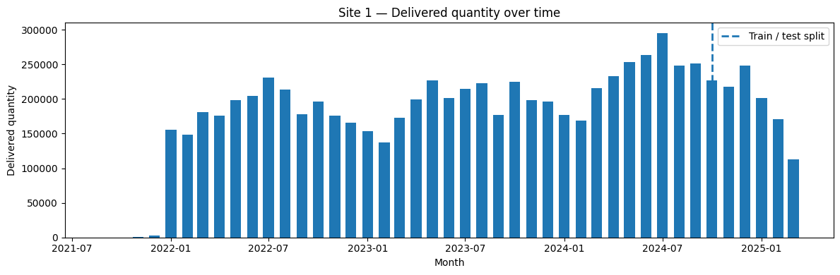
Raw Excel files were consolidated into a single Parquet file for efficiency. The data was split chronologically into training and test sets, with the test period covering the last six months.
Train/test separation :

2.2 Key Observations
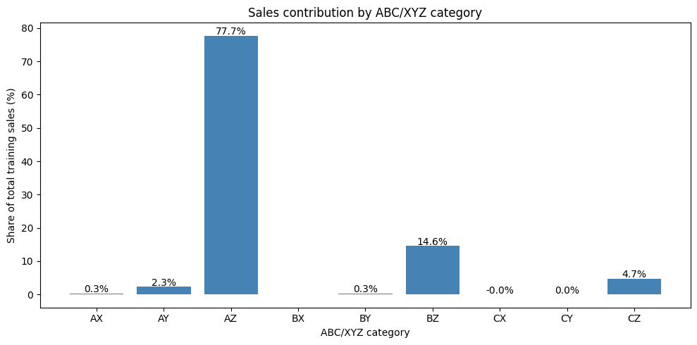
Three properties shaped all modelling decisions. First, demand is highly intermittent: most products show long zero-demand periods separated by occasional transactions (a pattern known to bias standard forecasting methods) [4]. Second, the portfolio is heterogeneous: a small number of AZ products account for over 77% of total sales volume, while the majority of references fall into class CZ. Third, temporal structure varies across products: some show clear seasonal patterns, others show none, making a uniform forecasting strategy unsuitable.

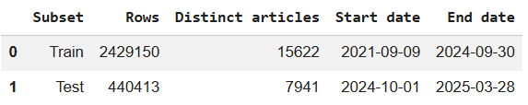

2.3 Initial Forecasting Approach
The baseline pipeline covers six steps: data preparation, ABC/XYZ classification, seasonality detection, demand forecasting, lead time analysis, and minimum stock computation.
ABC classification ranked products by cumulative delivered quantity using 80/95% thresholds. XYZ classification used the coefficient of variation (CV) of monthly demand: X for CV ≤ 0.10, Y for CV ≤ 0.30, and Z above [5]. Seasonality was detected using the autocorrelation function (ACF), selecting the strongest significant lag among 3, 4, 6, and 12 months [6].
Forecasting used three exponential smoothing variants: Simple Exponential Smoothing for stationary series, Holt's damped trend model without seasonality, and Holt-Winters when a valid seasonal period was detected [7]. Lead time mean and standard deviation were computed per product. Three minimum stock formulas were applied : F1 using mean values only, F2 adding demand uncertainty, and F3 incorporating both demand and lead time variability at a 99% service level.

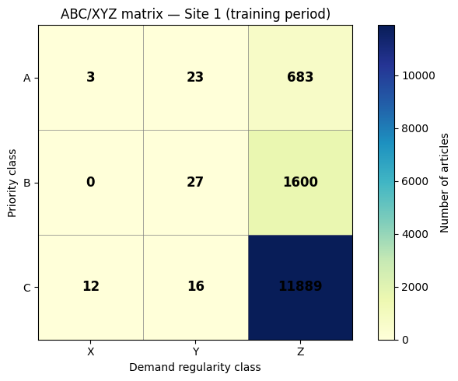
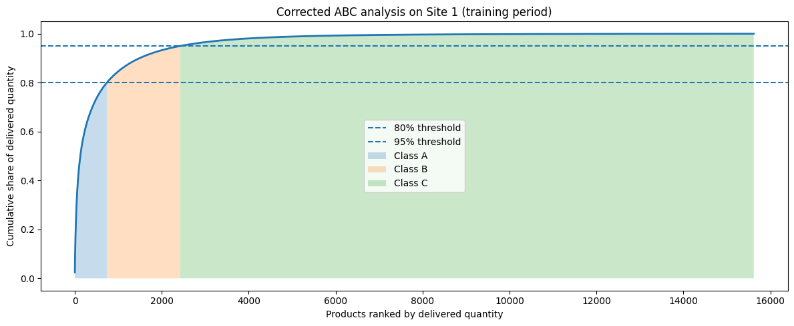

2.4 Initial Limitations
The baseline established a solid methodological foundation. Several limitations were nonetheless identified. The ABC/XYZ classification ignored product lifecycle: short-lived and discontinued references distorted CV estimates. ACF-based seasonality detection can capture indirect correlations between lags, which PACF corrects by isolating direct effects [6]. Mr. Terzi recommended PACF as a complementary tool. Exponential smoothing showed clear limits on intermittent series, with unstable MAPE on AZ products. Mr. Absi suggested neural networks as a stronger alternative for these profiles. Finally, AZ results (high volume, high variability) confirmed that a disaggregated category-level analysis would be necessary going forward.

3. From Initial Model to Improved Solution

3.1 Working Methodology
After completing the baseline implementation together, the team held a brainstorming session to identify improvement directions. Meetings with our supervisors Mr. Terzi and Mr. Absi and the Équipe X provided additional guidance. From these discussions, three main axes emerged: refining the ABC/XYZ classification using business data, improving seasonality detection, and exploring more adapted forecasting methods for intermittent demand.
The work was then divided. Walid focused on integrating business features into the ABC/XYZ classification. Samy explored PACF as a complementary seasonality diagnostic and contributed to forecasting improvements alongside Walid, including testing the SBA method. Salah took responsibility for the neural network implementation, which required sustained and focused effort over several days. During the final phase, the three worked jointly to consolidate results, ensure consistency across outputs, and prepare deliverables.
This exploratory phase lasted approximately ten days. It followed the same iterative logic as the baseline: propose a change, implement it, evaluate the impact, and decide whether to retain it.

3.2 Integrating Business Features to Improve ABC/XYZ Classification
The baseline XYZ classification had a structural weakness. The coefficient of variation was computed over the full available history of each product, regardless of whether the product was active during that period. New products with only a few months of history and discontinued products still present in the data were classified using incomplete or irrelevant demand series. This inflated variability estimates and produced unreliable XYZ assignments.
Walid corrected this by integrating product lifecycle data directly into the classification. For each product, the demand series used to compute the CV was restricted to its active period: from the earliest creation date to the latest cancellation date recorded for that product at Site 1. Products with no remaining data after this filter were assigned a missing class rather than a spurious one.
This correction had a concrete impact. Products that previously appeared highly variable simply because they were new or recently discontinued were reclassified more accurately. The resulting ABC/XYZ matrix better reflected the true operational profile of each reference. This is particularly important for AZ products, which represent over 77% of total sales volume: misclassifying these references would have directly affected stock decisions for the most business-critical items [5].

3.3 Handling Seasonality: From ACF to PACF
The baseline seasonality detection relied on the autocorrelation function (ACF). For each product, the ACF was computed at business-relevant lags (3, 4, 6, and 12 months) and the lag with the highest significant positive autocorrelation was selected as the seasonal period.
This approach has a known limitation. A significant ACF value at lag k does not necessarily indicate a direct seasonal relationship at that lag. If intermediate lags are also correlated, the ACF at lag k may simply reflect accumulated indirect effects [6]. Mr. Terzi raised this point and suggested using the partial autocorrelation function (PACF) as a complement.
The PACF measures the direct correlation between a series and its lagged version, after removing the influence of all intermediate lags. It therefore provides a cleaner signal of genuine periodicity. Samy implemented PACF-based seasonality detection using the same set of candidate lags. The selected lag was then used in the same Holt-Winters framework as before, producing a parallel forecast pipeline.
Both ACF-based and PACF-based forecasts were exported by ABC/XYZ category and compared. The PACF approach identified seasonal structure in a different subset of products, confirming that the two methods are genuinely complementary rather than redundant.
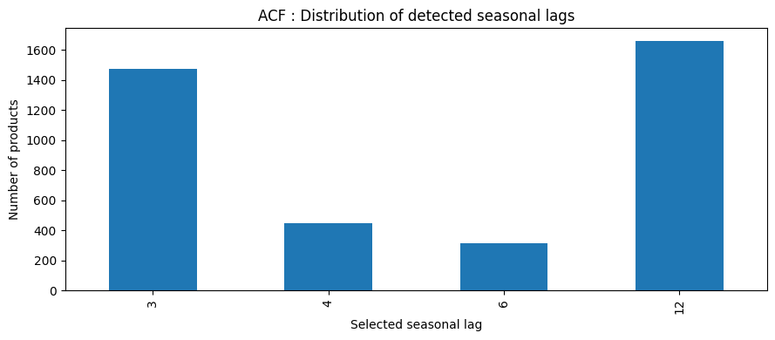
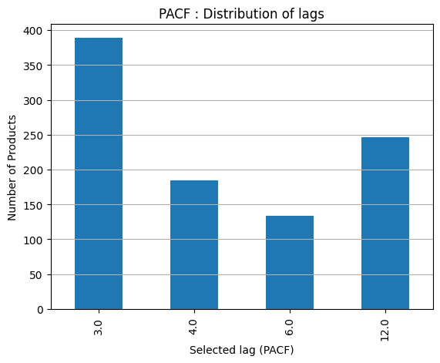

3.4 Forecasting Strategy Evolution

Exponential smoothing — revisited.
The baseline exponential smoothing pipeline was reviewed and corrected during this phase. One notable fix was the introduction of a damped trend in Holt's model, which prevents unrealistic long-term extrapolations for products with a short or noisy history [7]. A fallback mechanism using the median of the last three training observations was also added for products where all models failed to converge.
These corrections improved numerical stability across the catalogue. However, the fundamental limitation of exponential smoothing remained: on intermittent series — where demand is zero for many periods — these methods produce systematically biased forecasts. They assume some level of regularity that simply does not exist for most products in the portfolio [4].

Testing SBA.
To address intermittent demand, Walid and Samy explored the Syntetos-Boylan Approximation (SBA). SBA is a method specifically designed for intermittent demand series. It is derived from Croston's method and corrects a known bias in the original formulation by applying a scaling factor to the demand size estimate [4]. For products with sparse, irregular demand, SBA produces a stable long-run average rather than a dynamic monthly forecast.
The method was implemented and tested on AZ products, the most critical and most intermittent category. The results were informative but inconclusive for our use case. SBA produces a single constant value over the entire forecast horizon, which is appropriate for estimating a long-run average stock level, but not for generating dynamic monthly forecasts. As a result, SBA was not retained in the final pipeline. However, it confirmed that standard smoothing methods are structurally inadequate for this type of demand, and pointed clearly toward more flexible approaches.

Neural network.
Following Mr. Absi's recommendation, Salah implemented a neural network model as an alternative forecasting approach for intermittent demand series. The network takes monthly demand history as input alongside product-level features and learns non-linear demand patterns that rule-based methods cannot capture [8]. This approach is particularly promising for AZ products, which combine high sales volume with highly erratic demand (exactly the profile where a data-driven model can add the most value). The neural network results are discussed in Section 4.

3.5 Model Evaluation Strategy
All models were evaluated on the held-out test set using three metrics: Mean Absolute Error (MAE), Root Mean Squared Error (RMSE) and Mean Absolute Percentage Error (MAPE). MAPE was computed only on periods with non-zero actual demand to avoid division-by-zero distortions.
Evaluation was performed separately by ABC/XYZ category. This disaggregated approach was essential because global averages masked very different performance profiles across product types. A model performing well on CZ products (which represent the majority of references) could still fail badly on AZ products, which drive the majority of sales volume.
Stock coverage was assessed by comparing the minimum stock level produced by each formula (F1, F2, F3) against actual monthly demand over the test period. The proportion of months where the stock formula fully covered observed demand was computed per category, providing a direct, business-readable measure of formula adequacy

4. Results and Business Insights

4.1 Model Performance Comparison
Three models were evaluated across nine product segments classified by the ABC-XYZ matrix: Exponential Smoothing with ACF, Exponential Smoothing with PACF, and a Neural Network. Performance was measured using MeanMAE, MeanMAPE, and fill rates at three forecast horizons (F1, F2, F3).

Exponential Smoothing with ACF
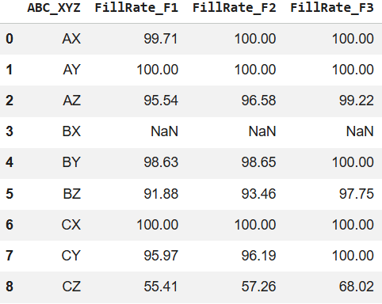
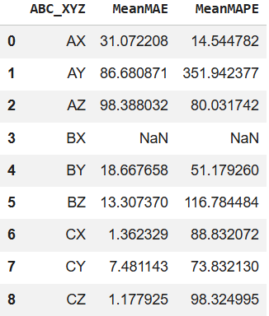
Forecasting Performance Fill rate

Exponential Smoothing with PACF
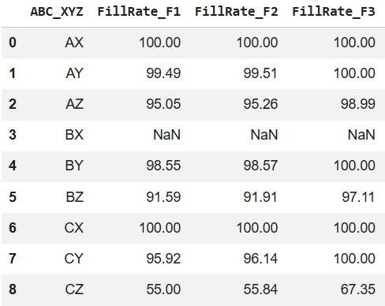
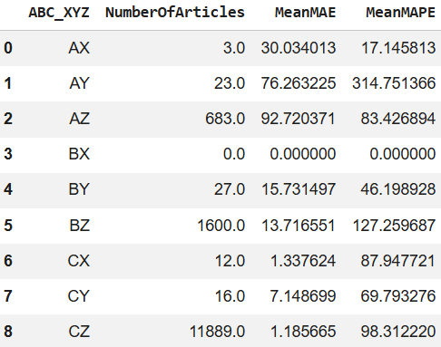
Forecasting Performance Fill rate

Neural Network
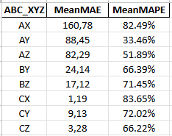
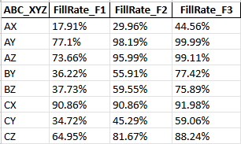
Forecasting Performance Fill rate

4.2 Interpretation of Results
The comparison of the three forecasting approaches shows that performance varies across categories and metrics. No model dominates in all situations.
The highest forecasting errors are observed for AY and AZ products. These categories remain difficult to predict due to demand variability. In these cases, exponential smoothing methods based on ACF and PACF provide similar results, and no clear advantage is observed.
The neural network brings a different contribution. It improves forecasting performance for Z categories, where demand is highly irregular. This suggests that data-driven approaches are better suited to capture complex patterns in intermittent demand.
AX products remain the easiest to forecast, which is consistent with their stable demand profile. In contrast, CZ products show a different behaviour. Mean Absolute Error remains relatively low, while Mean Absolute Percentage Error is very high. This is explained by low average volumes and intermittent demand. Small absolute deviations therefore lead to large percentage errors, making MAPE less informative for this category.
The comparison between ACF and PACF confirms that seasonality detection does not significantly affect forecasting performance. Both approaches identify different seasonal structures, but their overall impact remains limited. This indicates that seasonality is not the main source of forecasting difficulty in this dataset.
The most important observation appears when comparing forecasting metrics with fill rate results. Acceptable forecasting performance does not necessarily translate into satisfactory service levels. This gap is particularly visible for CZ products.

4.3 Impact on Inventory Decisions
From an inventory perspective, the results highlight clearer differences between approaches.
For AX and AY products, stock formulas perform well. Even the simplest formula ensures high service levels, confirming that forecasting outputs are sufficient for regular demand patterns.
For AZ and BZ products, increasing stock levels from F1 to F3 leads to significant improvements in fill rate. This shows that accounting for variability and uncertainty is necessary to compensate for forecasting errors.
The neural network provides an additional benefit for CZ products. While forecasting improvements remain limited in absolute terms, it leads to better stock coverage compared to exponential smoothing approaches. This indicates that improved modelling of intermittent demand can translate into more robust inventory decisions.
However, the main difficulty remains. Even with the most advanced stock formula, fill rates for CZ products remain below acceptable levels. This confirms that the current framework underestimates the impact of intermittent demand.
From a business perspective, this creates a risk of frequent stockouts. Forecasting models capture average behaviour but fail to anticipate demand spikes, leading to insufficient stock levels.

4.4 Key Takeaways
Several key insights emerge from this study.
First, no forecasting model is uniformly best across all categories. Model performance depends strongly on demand characteristics.
Second, forecasting accuracy alone is not sufficient to evaluate operational performance. Models can achieve acceptable error metrics while still leading to poor inventory outcomes.
Third, demand variability is the main driver of performance differences. Stable products can be managed with simple approaches, while intermittent demand requires more advanced methods.
Finally, inventory strategies must be adapted to demand profiles. Neural networks show potential for improving forecasting and stock management in highly variable categories, but standard approaches remain insufficient for intermittent demand. More robust or conservative strategies are required to reduce operational risk.

5. Limitations and Perspectives

5.1 Limitations
Data constraints
The study relies on a single site's transaction history, which limits the generalizability of the results. Several product references have short or incomplete demand series — either because they were recently introduced or because lifecycle data was missing. In both cases, the model receives insufficient signal to produce reliable forecasts. Segment CZ is the most affected: low volumes and frequent zero-demand periods make any statistical method structurally fragile on these references.

Modeling constraints
Exponential smoothing methods assume a degree of regularity in demand that does not exist for intermittent series. Even with lifecycle corrections and PACF-based seasonality detection, these methods remain inadequate for a large portion of the catalogue. The SBA method was tested but produces only a constant forecast, which is unsuitable for dynamic monthly replenishment decisions. The neural network shows promise but was trained on limited data. Deep learning models require large, dense datasets to generalize well — a condition that intermittent demand series rarely satisfy. As a result, the model's performance gains remain inconsistent across segments.
Evaluation constraint
MAPE becomes unreliable on near-zero demand periods, which are frequent in this dataset. This limits the comparability of error metrics across categories and makes global performance assessments harder to interpret.

5.2 Future Work
The most immediate improvement would be to apply the full pipeline to all warehouse sites in the Groupe X network, not just Site 1. Pooling demand data across sites would increase the volume of observations available per product, which would directly benefit neural network training and reduce the proportion of references with insufficient history.
On the forecasting side, methods specifically designed for intermittent demand deserve further investigation. The Syntetos-Boylan Approximation provided useful diagnostic insight in this study but was not retained for production. Croston's method and its variants, as well as probabilistic forecasting approaches such as quantile regression, could provide more robust estimates for Z-category products.
Finally, the minimum stock formulas could be extended to incorporate dynamic safety stock adjustments based on real-time lead time updates from suppliers. This would reduce the gap between the static model outputs and the operational reality of a distribution network subject to supply disruptions.

6. Conclusion
This project addressed the challenge of optimizing minimum inventory levels in a context of highly variable and intermittent demand. A complete data-driven pipeline was developed, combining ABC/XYZ classification, seasonality analysis, demand forecasting, and minimum stock computation.
The results confirm that forecasting performance strongly depends on demand characteristics. Exponential smoothing methods provide reliable results for stable products, but show clear limitations for intermittent demand. The neural network improves forecasting for Z categories and contributes to better stock coverage for CZ products, although gains remain limited.
A key finding is the gap between forecasting accuracy and inventory performance. Acceptable error metrics do not guarantee satisfactory service levels, especially for intermittent demand. This highlights the need to evaluate models not only on statistical accuracy, but also on their operational impact.
Overall, the study demonstrates that inventory strategies must be adapted to demand profiles. While standard approaches are sufficient for regular demand, more robust or conservative methods are required for highly irregular products. This provides a clear direction for future improvements in inventory management at Groupe X.

Appendix — Technical Focus

1. Seasonality Analysis: ACF and PACF
ACF. For each product, the ACF was computed at four business-relevant lags: {3, 4, 6, 12} months. A lag was retained only if its value exceeded 1.96/√n. Among all significant positive lags, the one with the highest ACF value was selected. The key limitation is that ACF at lag k captures both direct and indirect correlations: a significant value at lag 6 may simply reflect accumulated effects through lag 3, not genuine period-6 seasonality [6].
PACF implementation. PACF isolates the direct effect at each lag by partialling out all intermediate lags. It was computed using the Yule-Walker method (statsmodels pacf, method="ywm"). The maximum computed lag was capped at min(12, n//2 − 1) to ensure numerical stability. The same four candidate lags were screened with the same significance threshold 1.96/√n, and the lag with the highest value above threshold was selected. ACF and PACF pipelines ran fully independently, producing two parallel sets of seasonal assignments. Results were exported by ABC/XYZ category and compared directly, confirming that the two methods identify overlapping but non-identical subsets of seasonal products.

2. Forecasting Methods

Part 1 — Exponential Smoothing: improvements.
The baseline pipeline was corrected in two ways. First, Holt's model was switched to a damped trend formulation (damped_trend=True), preventing unrealistic extrapolation on products with noisy or short histories [7]. Second, a median fallback was added: when all models fail to converge, the forecast is set to the median of the last three training observations. Model selection remained automatic per product: Holt-Winters additive (trend="add", seasonal="add") when a valid seasonal lag existed and len(series) ≥ 2 × seasonal_lag, Holt damped otherwise. All outputs were clipped to zero. These methods remain structurally inadequate for intermittent series, where long zero-streaks violate regularity assumptions [4].

Part 2 — SBA.
SBA derives from Croston's method, which separately smooths demand size z_hat and inter-demand interval p_hat. Croston's estimator is positively biased; SBA corrects this by scaling the final output by (1 − α/2) [4]. The implementation initialised z_hat at the first non-zero observation and p_hat at 1.0. At each subsequent non-zero period, both were updated with α = 0.1: z_hat = α × val + (1 − α) × z_hat, p_hat = α × q + (1 − α) × p_hat, where q counts elapsed periods since the last demand event. The final forecast is (1 − α/2) × z_hat / p_hat — a single constant value over the full horizon. This is appropriate for long-run average stock estimation but incompatible with dynamic monthly forecasting. SBA was tested on AZ products and subsequently removed from the pipeline.

Part 3 — Bidirectional LSTM with Zero-Inflated head.
The model was implemented in PyTorch and trained on GPU.

Architecture.
A 2-layer bidirectional LSTM (hidden size 64, dropout 0.25 between layers) processes input sequences of length SEQ_LEN = 12 months. The final hidden state (dimension 128 after concatenating both directions) is passed through LayerNorm, then concatenated with 4 static features before entering a 2-layer MLP [64, 32] with GELU activations, LayerNorm, and Dropout(0.40). The output head is Zero-Inflated: it produces three outputs — a final forecast fp, a quantity estimate qp, and a zero-probability zp — with final prediction = qp × (1 − zp).

Input features.
Sequential numerical features (13): cyclic month encoding (sin/cos), cyclic quarter encoding (sin/cos), lags 1–3, 3- and 6-month rolling means, 3-month rolling standard deviation, zero-frequency rate, lagged revenue (ca_lag1), and unit price. Categorical features: product category, tariff family, sub-family, warehouse, client profession, and client territory — each integer-encoded and passed through a learned embedding of dimension min(6, (cardinality+1)//2 + 1). Static numerical features (4): year, quarter, 6-month linear trend (trend_6m), and product seniority (anciennete). All numerical features were normalised with RobustScaler fitted on the training set only.

Target and training.
The target was log1p(monthly demand), reversed at inference with expm1. Sequences were built with a sliding window of 12 months per article; short-history products were left-padded with zeros. The dataset was split chronologically: the test set covers PRED_START to PRED_END; the validation set is the last 15% of remaining sequences. Training used AdamW (lr = 10⁻³, weight_decay = 5×10⁻⁴) with ReduceLROnPlateau (factor 0.5, patience 5, min_lr = 10⁻⁶), gradient clipping at norm 1.0, and a custom ZeroInflatedLoss (α = 0.4, β = 0.3, peak_weight = 2.5) penalising both zero misclassification and magnitude error. Training ran for up to 80 epochs (batch size 256) with early stopping (patience = 12) and best-model checkpointing on validation loss.

References
[1] Silver, E. A., Pyke, D. F., & Thomas, D. J. (2017). Inventory and Production Management in Supply Chains (4th ed.). CRC Press.
[2] Chopra, S., & Meindl, P. (2016). Supply Chain Management: Strategy, Planning, and Operation (6th ed.). Pearson.
[3] Croston, J. D. (1972). Forecasting and stock control for intermittent demands. Operational Research Quarterly, 23(3), 289–303.
[4] Syntetos, A. A., & Boylan, J. E. (2005). International Journal of Forecasting, 21(2), 303–314.
[5] Flores, B. E., & Whybark, D. C. (1986). International Journal of Operations and Production Management, 6(3), 38–46.
[6] Box, G. E. P., Jenkins, G. M., Reinsel, G. C., & Ljung, G. M. (2015). Time Series Analysis (5th ed.). Wiley.
[7] Hyndman, R. J., & Athanasopoulos, G. (2021). Forecasting: Principles and Practice (3rd ed.). OTexts.
[8] Benidis, K., Rangapuram, S. S., Flunkert, V., Wang, B., Maddix, D., Turkmen, C., Gasthaus, J., Bohlke-Schneider, M., Salinas, D., Stella, L., Callot, L., & Januschowski, T. (2022). Deep learning for time series forecasting: Tutorial and literature survey. ACM Computing Surveys, 55(6), 1–36.

